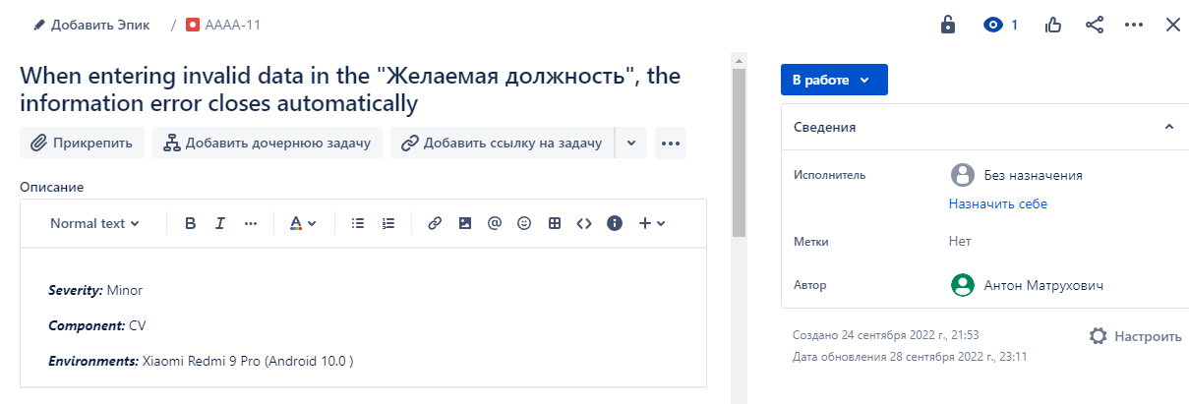

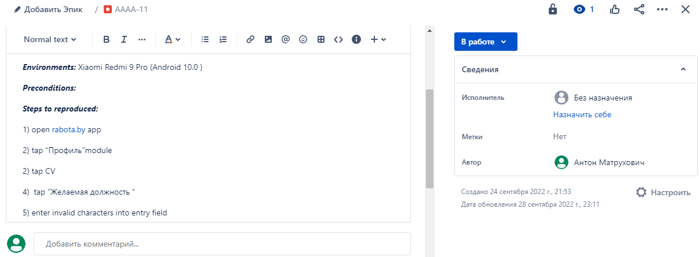

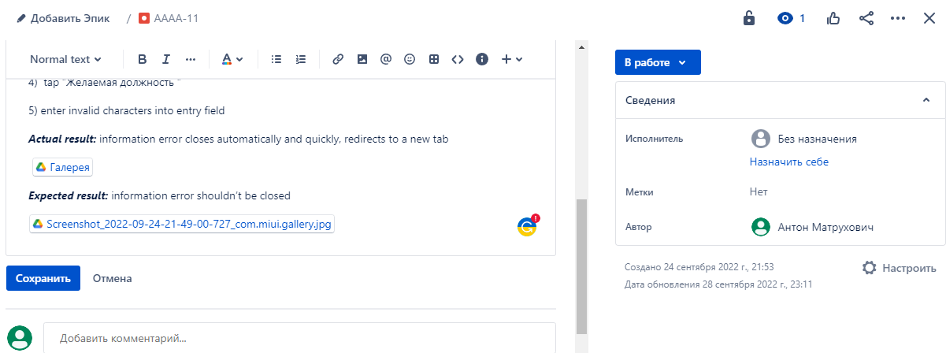

LINK: awwev.atlassian.net/jira/software/projects/AAAA/boards/1?selectedIssue=AAAA-11

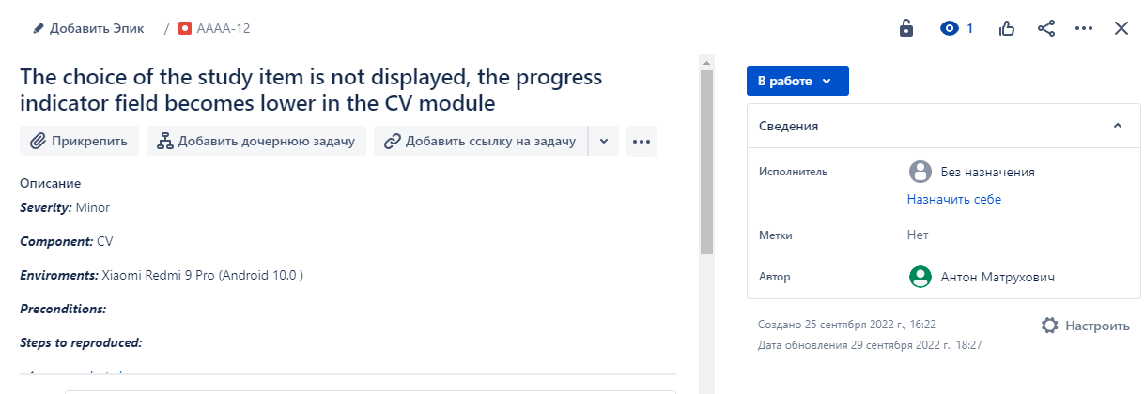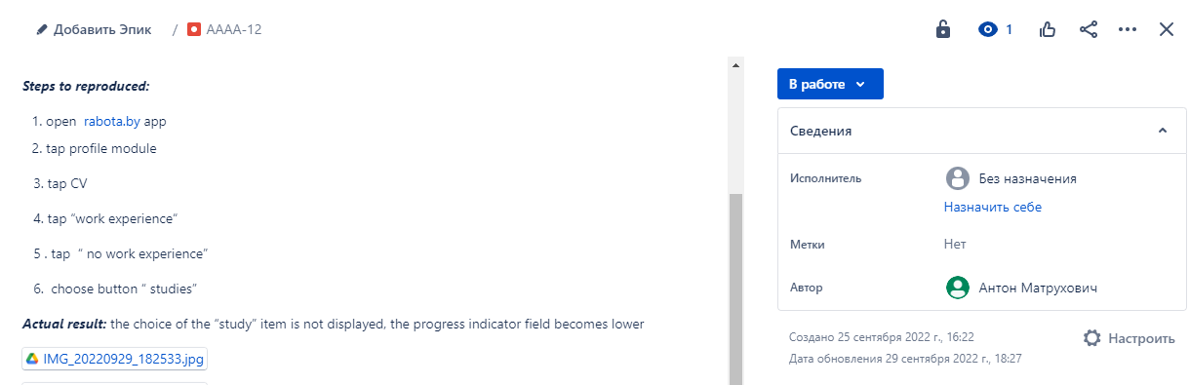

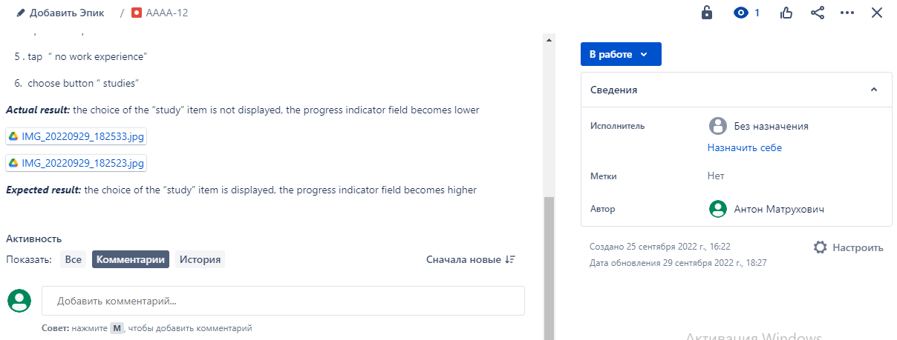 LINK: <https://awwev.atlassian.net/jira/software/projects/AAAA/boards/1?selectedIssue=AAAA-12>

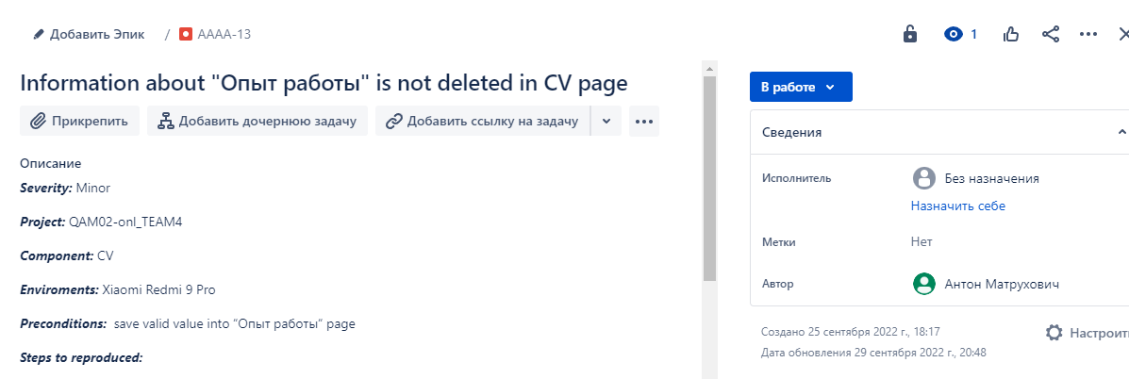

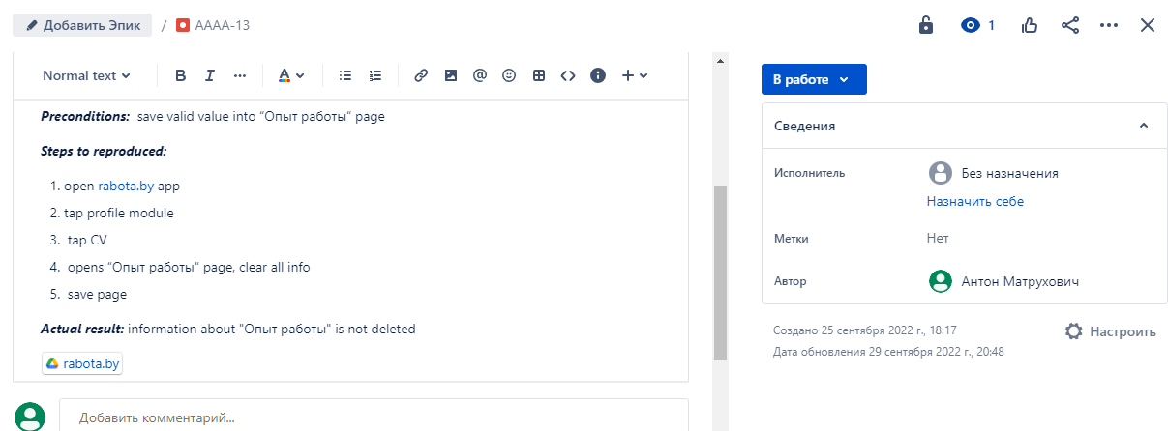

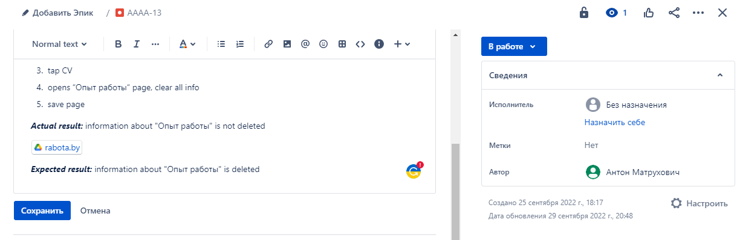

LINK: https://awwev.atlassian.net/jira/software/projects/AAAA/boards/1?selectedIssue=AAAA-13